**Assignment #1**

*(LO 1)*

Name: Abdurrahman bin Kamarulariffin Matric No:1622031

1. By using google colab code to access your webcam, capture three different facial expressions of yourself.

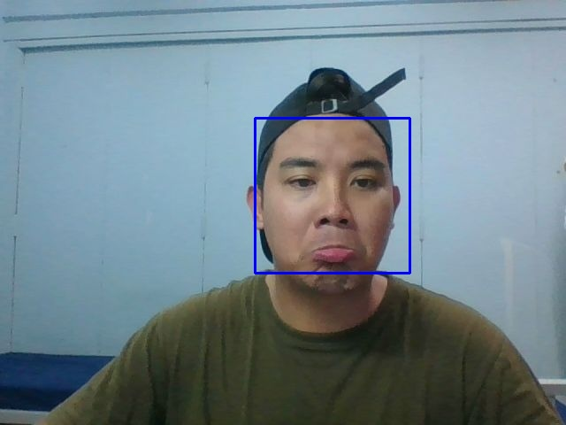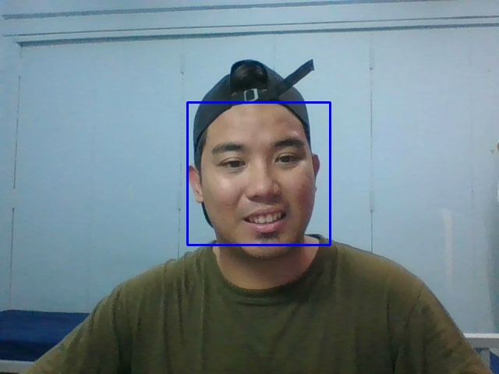

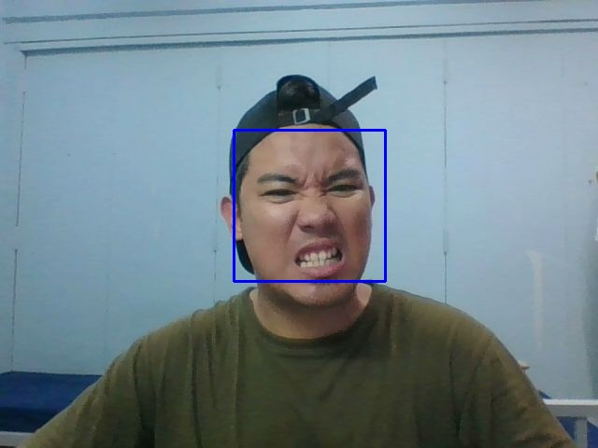

1. Apply both Canny Edge Detection and Sobel Edge Detection to only the face area of the image using suitable threshold values. (5 Marks)

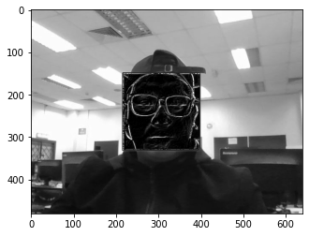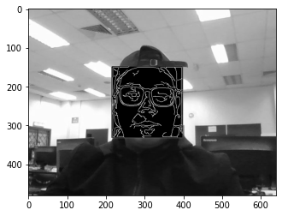

sobel canny

1. Perform blurring of only faces in those images. (5 Marks)

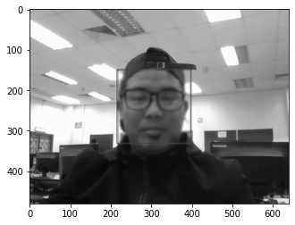

1. Calculating the number of coins in an image using contours. (5 Marks)

